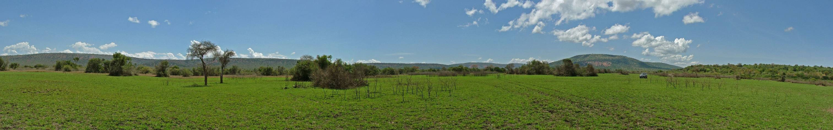

Geloof, Hoop En Liefde

Newsletter January - March 2009
GeloofHoopEnLiefdeRwanda@Yahoo.com www.GeloofHoopEnLiefdeRwanda.nl


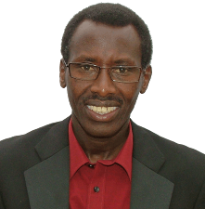
Dear Friends,
Receive many greetings from our volunteers in Rwanda and from us here in Holland.
The Foundation Stichting Geloof Hoop En Liefde in Holland has founded: “Association Hope” in Rwanda. We are helping Orphans, Aids-Children, Youth and Widows. See video images on;
www.GeloofHoopEnLiefdeRwanda.nl

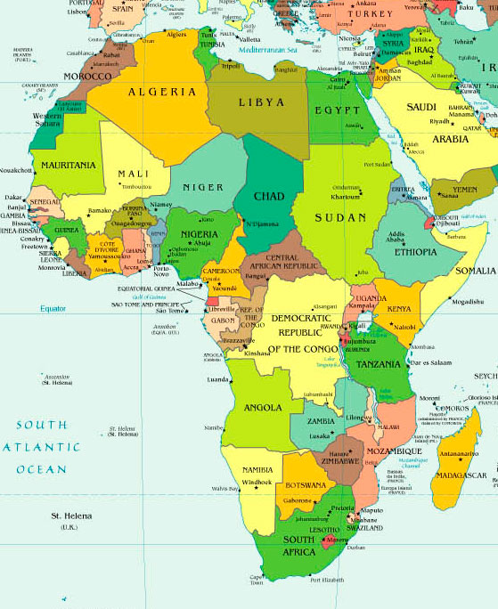
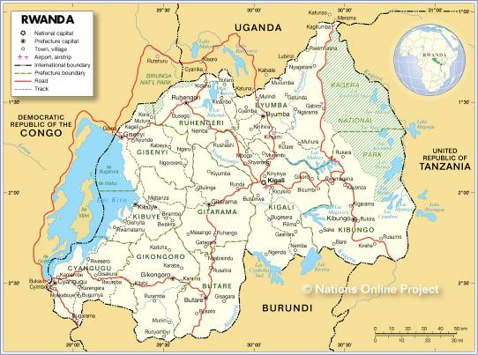

Peter Gatete
Founder / Chairman



In a very poor neighborhood we have started helping the children some years ago. As the center for our work we use a small building which also serves as church. In our last visit to Rwanda we felt a great need to improve our church. The church is very full and the building is being rented, and the walls are built of mud without a solid floor. The fact that the floor is just soil, makes it that a lot of dust goes into the air during the meetings. We are having our eye on a piece of land from where we can better serve the people in the neighborhood. On this terrain we First want to built the church. It will be a simple church but with a good Floor, windows and doors so it can be closed properly so proper help can be provided to the people. There are no churches nearby, so it is a great pioneering opportunity to start this ministry to so being able to proclaim the joyous message of Jesus Christ in Word and in deed.
The rented building is too small, and we know that we can easily double the amount of members if we provide more space.

Rwanda; Altitude 1500 m Temp. 23°C
http://en.wikipedia.org/wiki/Rwanda

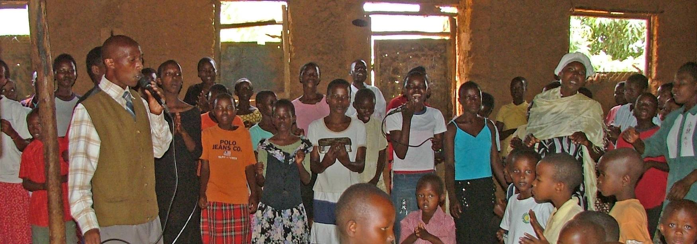

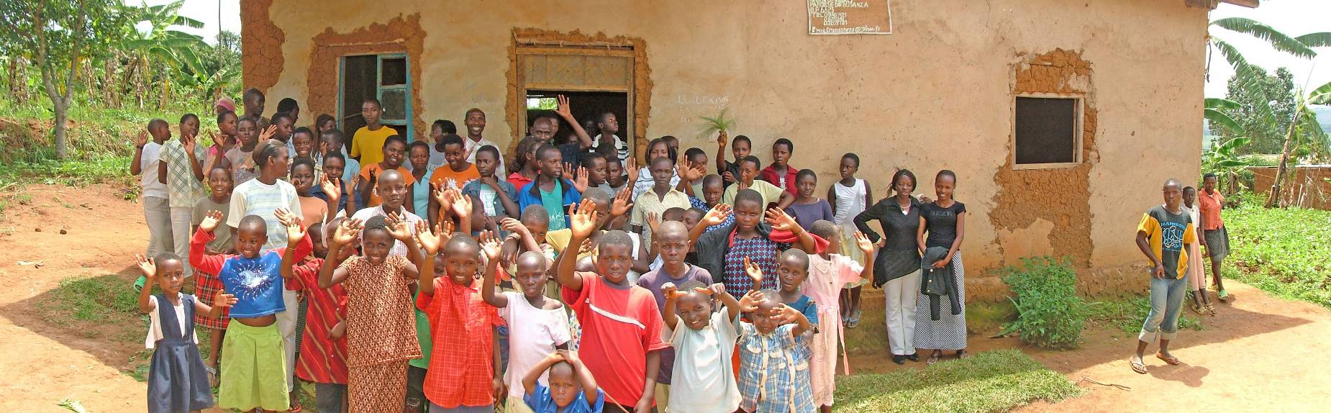

The building project;
With this letter we want to present the need to you in our ministry in the work we do in Rwanda, Africa, among the widows, orphans and the victims of the genocide of 1994.

Who are we?
We are a Christian foundation based in Enkhuizen. This foundation was born from the heart of our chairman, Peter Gatete, who wants to serve the war victims. Peter is born in Rwanda and lives in Enkhuizen and is married to a Dutch women. They have 4 beautiful children, two boys and two girls.
www.GeloofHoopEnLiefdeRwanda.nl

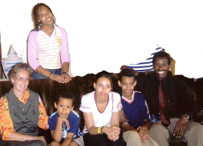
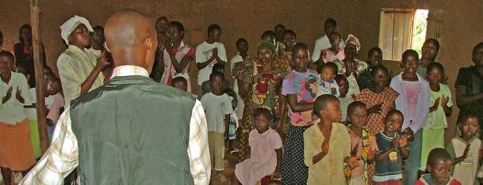

Staff in Holland; Peter Gatete, Frans Nijhof, Martin Haring, Marjan Gatete, Bas Roemers, Paul de Kloe.

Foundation Stichting Geloof Hoop En Liefde; As foundation we offer spiritual and material help to the traumatized people of Rwanda, by means of; The Sewing school, The Aids-Project, The Church, and the Vegetable garden.

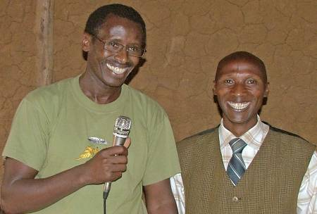
Peter and Pastor Faustin
Faustin Munyaneza, a pastor, is one of our 5 volunteers and links in Rwanda. He is a faithful person who has committed himself many years as a volunteer for the foundation. We want to appoint him as pastor and overseer of the new expansion so that he can even more develop his talents for God even more and that God can lead him further. (see pictures). The congregation he leads has a potential and can be seen as a district congregation, on a location which is accessible for everyone.

Without this church it would be very far walking to visit a church on Sunday. From this building Faustin Munyaneza also leads the Aids-project. We also take care for 64 children so that they can go to school, children who themselves have Aids, or their parents have Aids, of whom mostly already died.
The cost of the terrain and building are 20.000,-- Euro. We like to ask you for your help for a donation.
Possibly you can also organize a fundraising for this project in your church, Company, workgroup, Club or friends group.

1 Corinthians 13:13 And now abideth faith, hope, charity, these three; but the greatest of these is charity.

Friendly greetings and thank you very much for your support, God bless you



For international donations;
Postbank 6931133
IBAN: NL 61 PSTB 0006931133
BIC: PSTBNL21

ABN bank 49.20.56.056
IBAN: NL 05 ABNA 0492056056
BIC: ABNANL2a
Stichting Geloof Hoop En Liefde
Poortland 53 Postbank 6931133
1602 MC Stg Geloof
Enkhuizen Hoop En Liefde
+31 228 316646
www.GeloofHoopEnLiefdeRwanda.nl

Do you like to receive this newsletter by Email? Please send us your Email to; GeloofHoopEnLiefdeRwanda@Yahoo.com
See this Newsletter on the web and freely forward this link to others: http://www.Newsletter.GeloofHoopEnLiefdeRwanda.nl

